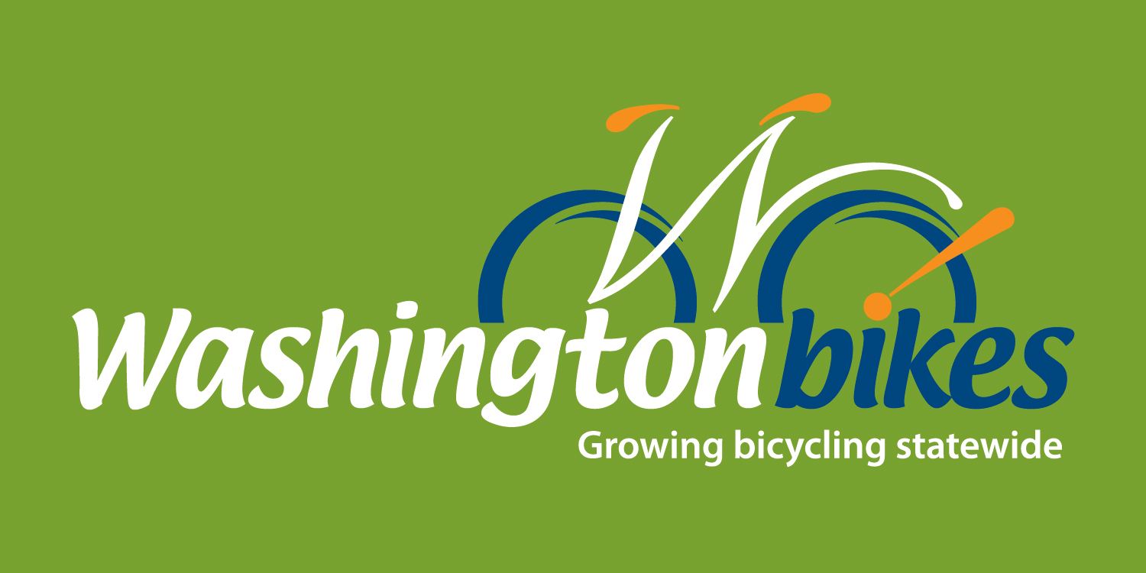

The City/County of ____

Proclamation

Whereas, the bicycle is a healthy, convenient, financially and environmentally sound form of transportation and an excellent tool for recreation and enjoyment of [insert city/county]’s scenic beauty, local attractions, and friendly neighborhoods; and

Whereas, throughout the month of May, the residents of [insert city/county] and its visitors will experience the joys of bicycling through educational programs, commuting events, Bike to School Day, trail work days, helmet promotions, charity events, races, or by simply getting out and going for a ride; and

Whereas, [insert city/county]’s road and trail system attracts bicyclists each year, providing economic health, transportation, tourism, and scenic benefits; and

Whereas, support for bicycling in [insert city/county] contributes to Washington’s #1 Bicycle Friendly State ranking (2008-2014); and

Whereas, creating a bicycling-friendly community has been shown to improve citizens’ health, well-being, and quality of life, growing the economy of [insert city/county], attracting tourism dollars, improving traffic safety, supporting student health and learning, and reducing pollution, congestion, and wear and tear on our streets and roads; and

Whereas, Washington Bikes, [insert local bicycle club/ organization/chamber/tourism bureau], the League of American Bicyclists, schools, parks and recreation departments, police departments, public health districts, health care providers, companies and civic groups will be promoting bicycling during the month of May YEAR; and

Whereas, these groups are also promoting bicycle tourism year round to attract more visitors to enjoy our local restaurants, hotels, retail establishments, local foods and beverages, and cultural and scenic attractions; and

Whereas, these groups are also promoting greater public awareness of bicycle operation and safety education in an effort to reduce collisions, injuries, and fatalities and improve health and safety for everyone on the road; and

Now therefore, I, _____, Mayor/Executive of [insert city/county], do hereby proclaim May YEAR as

Bike Month

in [insert city/county], and I urge all residents to join me in this special observance

Signed this ___ day of May, YEAR

Mayor/Executive _______________

