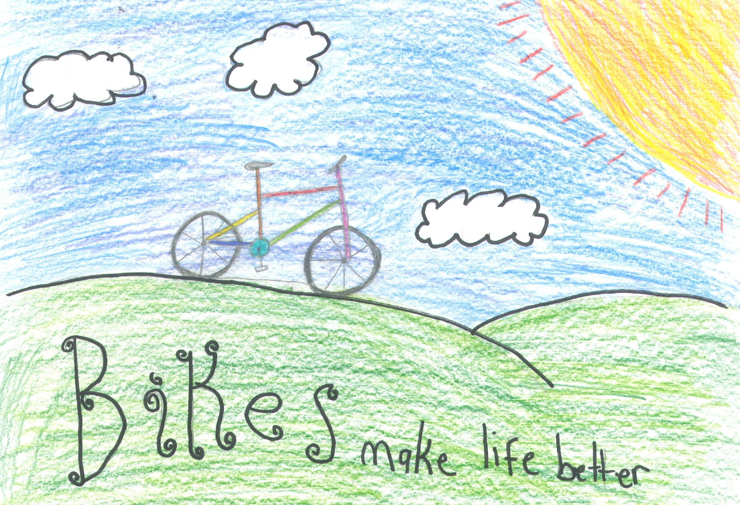
Bike to School Day!
May 7th
Mackenzie of Port Angeles, WA
RIDE TO SCHOOL ~ CELEBRATE BIKING ~ JOIN THE FUN Get involved at www.WaBikes.org contact seth@WaBikes.org
ride to school – ride to school – ride to school – ride to school – ride to school – ride to school – ride to school – ride to school – ride to school – ride to school – ride to school – ride to school – ride to school – ride to school – ride to school – ride to school – ride to school – ride to school – ride to school – ride to school – ride to school – ride to school – ride to school – ride to school – ride to school – ride to school – ride to school – ride to school – ride to school – ride to school– ride to school – ride to school – ride to school – ride to school – ride to school – ride to school – ride to school – ride to school – ride to school – ride to school – ride to school – ride to school – ride to school – ride to school – ride to school – ride to school – ride to school – ride to school – ride to school – ride to school – ride to school – ride to school – ride to school – ride to school – ride to school – ride to school – ride to school – ride to school – ride to school– ride to school – ride to school– ride to school – ride to school – ride to school – ride to school

